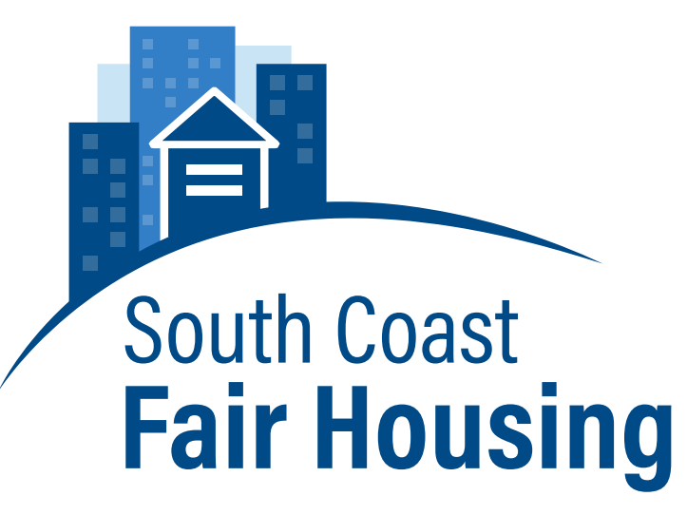
FOR IMMEDIATE RELEASE
March 10, 2016

Kristina da Fonseca
Executive Director
(774) 473-8333
kristina@southcoastfairhousing.org
www.southcoastfairhousing.org

Fair Housing Resources Become Available to South Coast Residents

NEW BEDFORD, MA- It’s no secret that the housing market has been tumultuous in the past decade, and navigating these treacherous waters only becomes more complicated when you have civil rights matters to consider. Whether you are looking to buy your first home, dealing with tenant concerns as a landlord, or for that matter, dealing with landlord concerns as a tenant, your civil rights are protected by federal and state laws—laws which are not always clear to the average person.

Helping to clarify these issues is SouthCoast Fair Housing, a nonprofit that operates out of New Bedford. Formed in 2012, SCFH provides presentations, trainings and workshops for first-time homebuyers, staff of housing authorities and service providers, real estate agents and brokers, community members, local officials, landlords, and volunteers. Despite its critical mission of eradicating housing discrimination and increasing housing opportunities, SCFH is the only fair housing organization in Bristol County, and also serves Plymouth County. SCFH is a supporting member of the National Fair Housing Alliance.

With the support of a Fair Housing Initiatives Program grant from the Department of Housing and Urban Development, SCFH has redeveloped its website (southcoastfairhousing.org) and is expanding its social media presence. SCFH hopes residents will use its website to learn about fair housing and opportunities to get involved. Additional resources include informational brochures available in English, Spanish, and Portuguese. Leveraging the expertise of Civic Support, a non-profit organization that provides affordable outreach strategies to community organizations, SCFH will continue to expand the resources available online for locals seeking information about fair housing and housing discrimination.

Fair Housing in the SouthCoast region is especially important. Housing segregation persists in the SouthCoast. According to data from the 2010 U.S. Census, the Providence-New Bedford-Fall River metropolitan area is the fourth most segregated in the country, between individuals who identified as White, and those who identified as Hispanic. With a Dissimilarity Index of sixty, 60% of Hispanics in the region would need to move to be distributed across the region exactly as Whites. Additionally, more than 50% of people who identify as Black in the region and 40% of people who identify as Asian would need to move to be distributed exactly as Whites.

Location matters in terms of access to education, economic and social opportunities. Housing segregation leads to segregated schools, and all too often, differences in opportunity. Transportation, zoning, housing affordability, and housing discrimination can contribute to segregation and limited housing choice. Advancement of equal housing opportunities across the region requires a commitment to affirmatively furthering fair housing by residents, municipalities, public and private housing providers, businesses, non-profits, and community organizations. Since its formation, SCFH has been working to raise awareness of fair housing across the region and is continuing to develop partnerships with a variety of entities.

On Wednesday, March 16, 2016 from 4:30-6:30 PM, SouthCoast Fair Housing will be hosting an Open House at 257 Union Street, in New Bedford. This event is open to all members of the public, whether you are looking for resources on fair housing or hoping to volunteer for a cause that is highly important in the SouthCoast community. If you are unable to attend but are still interested in learning more about SCFH, you can visit their new website at www.southcoastfairhousing.org.

###

SouthCoast Fair Housing (SCFH) is a private, non-profit fair housing organization established in 2012. SCFH’s mission is to eradicate housing discrimination, increase equal housing opportunities, and help develop inclusive communities. SCFH works to accomplish these goals through education and outreach, advocacy, and enforcement activities. For more information, please visit www.southcoastfairhousing.org, or contact executive director Kristina da Fonseca by emailing Kristina@southcoastfairhousing.org.

See data compiled by the Population Studies Center Institute for social Research. http://www.psc.isr.umich.edu/dis/census/segregation2010.html

